Custom Training

Day 13

**Python**

Data Types supported in Python:

1. Integer: Whole numbers.
2. Float: Decimal values.
3. String: Textual values.
4. List: It is mutable.
5. Tuple: It is immutable.
6. Dictionary: Key – value pairs.
7. Boolean: True, False

Tuple is fast compared to a list.

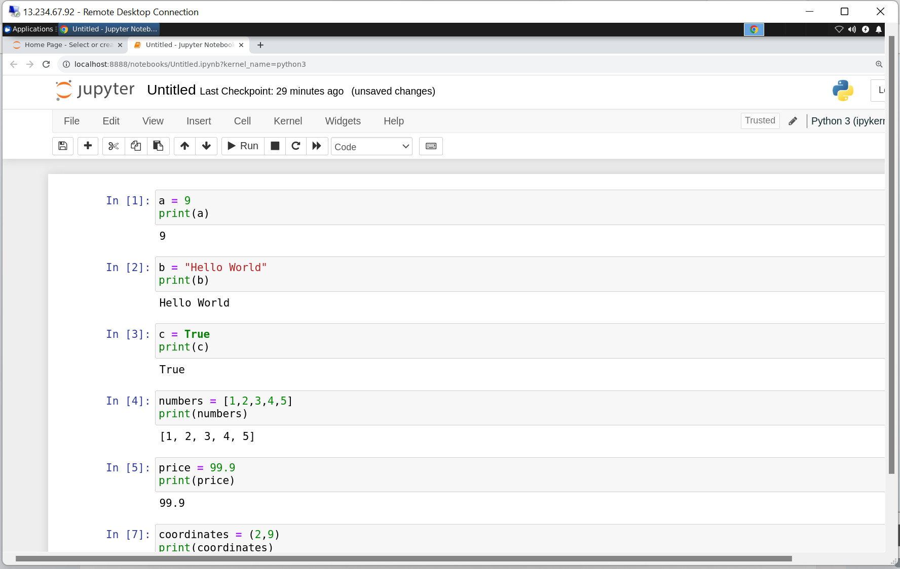

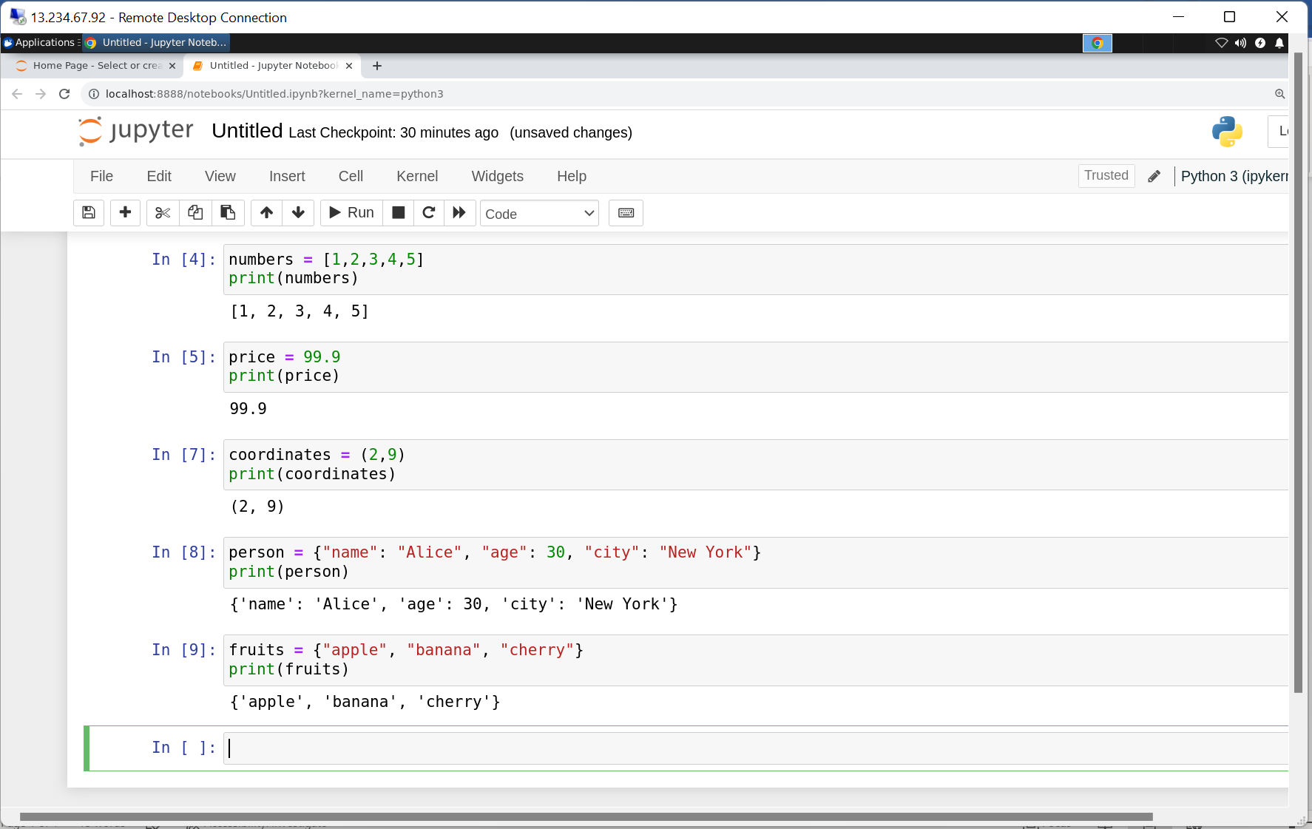

Operators:

1. Arithmetic Operators: plus, minus, modulus, multiply, divide, exponent
2. Logic Operators: AND, OR, NOT
3. Membership Operators: in, not in

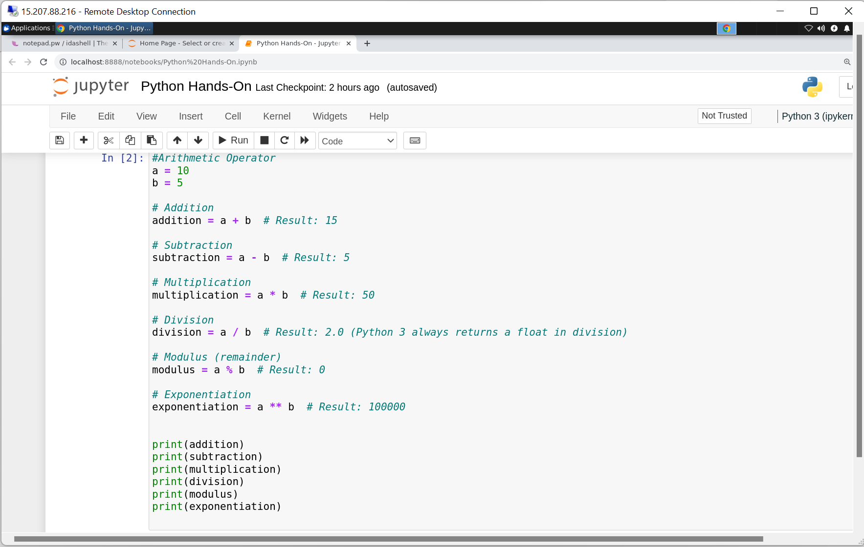

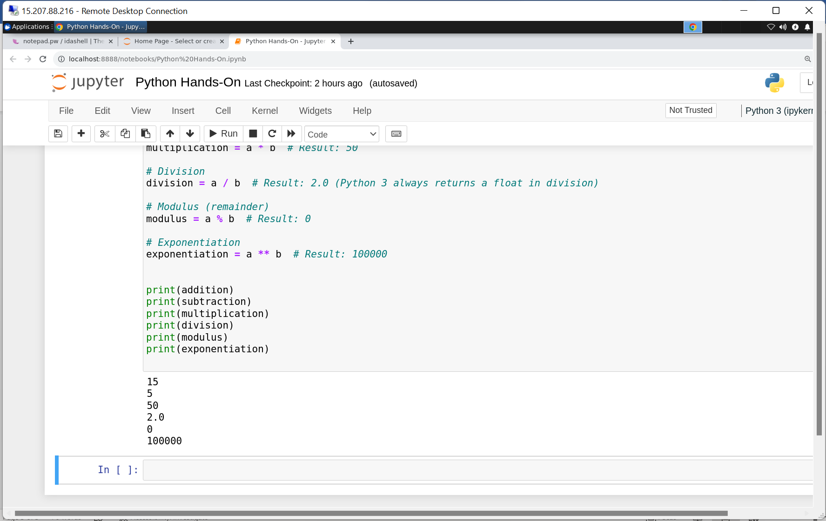

Practice Question:

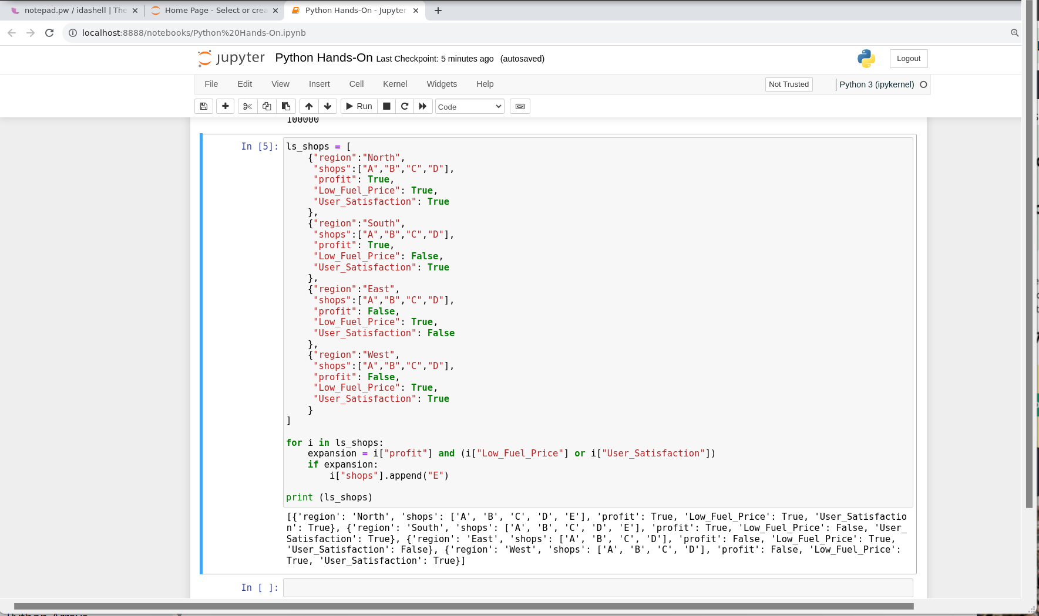

Zip function: Creates a tuple of two or more items or collections. Both the collection should have same number of columns because it combines pair wise on each index.

Enumerate function: Used to get the index value.

Counter function: If we have any collection, it will calculate how many occurrence of each item in collection is there and gives output in the form of dictionary.

String Interpolation: To format the string it is used.

Function: Piece of code used for code reusability.

